National University of Computer and Emerging Sciences



Laboratory Manual

for

Programming Fundamentals

|  |  |
| --- | --- |
| Course Instructor | Mr. Waqas Manzoor |
| Lab Instructor(s) | Miss Shazia Ahmed  Mr. Adeel Qayyum |
| Section | PF E |
| Semester | Fall 2020 |

Department of Computer Science

FAST-NU, Lahore, Pakistan

Table of Contents

If statement 3

Syntax: 3

How if statement works? 3

Example 1: if statement 4

if...else Statement 5

How if...else statement works? 5

Example 2: if...else statement 6

if...else if…. else 7

Syntax of if...else if…. else 7

Example 3: if...else Ladder 8

Nested if...else 9

Example 4: Nested if...else 9

Operators Precedence 11

Program 11

output 11

Operator Precedence Table 12

While Loop 12

Pseudocode 12

Solution 12

InLab Problems: 12

Lab Manual 03

Objective

If statement, if-else and nested if-else statements

# If statement

## Syntax:

if (Condition)

{

// statements to be executed if the test expression is true

}

## How if statement works?

The **if** statement evaluates the test expression inside the parenthesis **()**.

* If the test expression is evaluated to true, statements inside the body of **if** are executed.
* If the test expression is evaluated to false, statements inside the body of **if** are not executed.

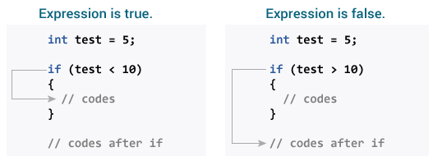

## Example 1: if statement

#include <iostream>

using namespace std;

int main() {

int number;

cout<<"Enter an integer: ";

cin>> number;

// true if number is less than 0

if (number < 0) {

cout<<"You entered” << number<<endl;

}

cout<<"The if statement is easy.";

return 0;

}

**Output 1**

Enter an integer: -2

You entered -2.

The if statement is easy.

**Output 2**

Enter an integer: 5

The if statement is easy.

# if...else Statement

The **if**statement may have an optional else block. The syntax of the if..else statement is:

if (test expression) {

// statements to be executed if the test expression is true

}

else {

// statements to be executed if the test expression is false

}

## How if...else statement works?

If the test expression is evaluated to true,

* statements inside the body of if are executed.
* statements inside the body of else are skipped from execution.
* If the test expression is evaluated to false,
* statements inside the body of else are executed
* statements inside the body of if are skipped from execution.

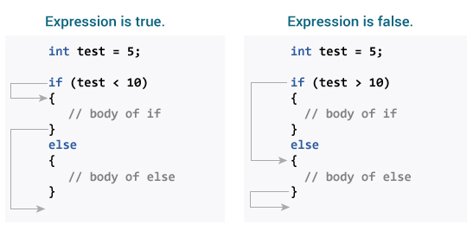

## Example 2: if...else statement

// Check whether an integer is odd or even

#include <iostream>

using namespace std;

int main() {

int number;

cout<<"Enter an integer: ";

cin>> number;

// True if the remainder is 0

if (number%2 == 0) {

cout<< number <<" is an even integer.";

}

else {

cout<< number << “ is an odd integer.";

}

return 0;

}

**Output**

Enter an integer: 7

7 is an odd integer.

When the user enters 7, the test expression number%2==0 is evaluated to false. Hence, the statement inside the body of else is executed.

# if...else if…. else

The if...else statement executes two different codes depending upon whether the test expression is true or false. Sometimes, a choice has to be made from more than 2 possibilities.

The if...else ladder allows you to check between multiple test expressions and execute different statements.

## Syntax of if...else if…. else

if (test expression1) {

// statement(s)

}

else if(test expression2) {

// statement(s)

}

else if (test expression3) {

// statement(s)

}

.

.

else {

// statement(s)

}

## Example 3: if...else Ladder

// Program to relate two integers using =, > or < symbol

#include <iosteam>

using namespace std;

int main() {

int number1, number2;

cout<<"Enter two integers: ";

cin >> number1 >>number2 ;

//checks if the two integers are equal.

if(number1 == number2) {

cout<<"Result: “ <<number1 << “ = ” << number2;

}

//checks if number1 is greater than number2.

else if (number1 > number2) {

cout<<"Result: “ <<number1 << “ > ” << number2;

}

//checks if both test expressions are false

else {

cout<<"Result: “ <<number1 << “ < ” << number2;

}

return 0;

}

**Output**

Enter two integers: 12

23

Result: 12 < 23

# Nested if...else

It is possible to include an if...else statement inside the body of another if...else statement.

## Example 4: Nested if...else

This program given below relates two integers using either <, > and = similar to the if...else ladder's example. However, we will use a nested if...else statement to solve this problem.

#include <iostream>

using namespace std;

int main() {

int number1, number2;

cout << “Enter two integers: ";

cin>>number1 >> number2;

if (number1 >= number2) {

if (number1 == number2) {

cout<<"Result: “ <<number1 << “ = ” << number2;

}

else {

cout<<"Result: “ <<number1 << “ > ” << number2; }

}

else {

cout<<"Result: “ <<number1 << “ < ” << number2;

}

return 0;

}

If the body of an if...else statement has only one statement, you do not need to use brackets {}.

For example, this code

if (a > b) {

print("Hello");

}

print("Hi");

is equivalent to

if (a > b)

print("Hello");

print("Hi");

# Operators Precedence

Check the simple difference with and without parenthesis. This will produce different results because (), /, * and + have different precedence. Higher precedence operators will be evaluated first.

## Program

#include <iostream>

using namespace std;

main() {

int a = 20;

int b = 10;

int c = 15;

int d = 5;

int e;

e = (a + b) * c / d; // ( 30 * 15 ) / 5

cout << "Value of (a + b) * c / d is :" << e << endl ;

e = ((a + b) * c) / d; // (30 * 15 ) / 5

cout << "Value of ((a + b) * c) / d is :" << e << endl ;

e = (a + b) * (c / d); // (30) * (15/5)

cout << "Value of (a + b) * (c / d) is :" << e << endl ;

e = a + (b * c) / d; // 20 + (150/5)

cout << "Value of a + (b * c) / d is :" << e << endl ;

return 0;

}

## output

Value of (a + b) * c / d is :90

Value of ((a + b) * c) / d is :90

Value of (a + b) * (c / d) is :90

Value of a + (b * c) / d is :50

## Operator Precedence Table

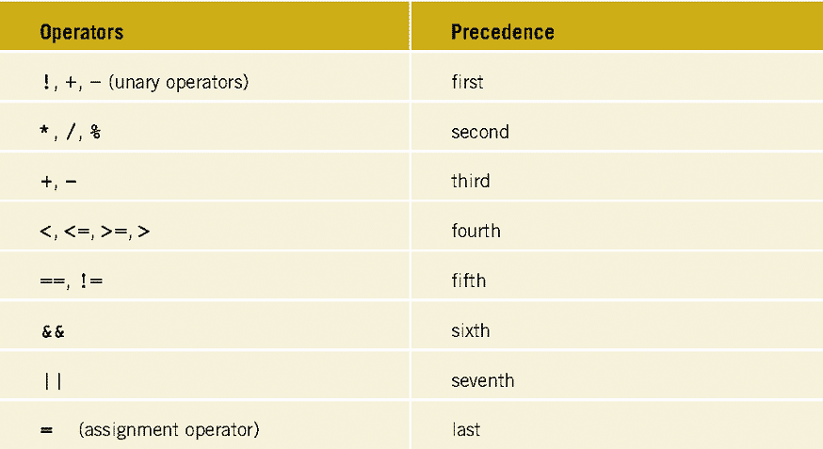

# While Loop

The while loop is used to repeat a section of code an unknown number of times until a specific condition is met.

## Pseudocode

Write a **Pseudocode**  that get a number from user and check how many times a number can be divisible by 2 to become lesser then 1.

## Solution

  get our number   
                set our initial count to 0   
                **while** our number is greater than 1   
                  divide the number by 2   
                  increase our count by 1   
                **end** 

# InLab Problems:

## Operator Precedence

1. Write C++ program to evaluate the expression



1. Write C++ program to evaluate the expression  
     
   take x, y and z input from user
2. What will be the Output of   
   

## Pseudocode

1. Write a **Pseudocode** to get a number from the user and print whether it is positive or negative.
2. Write a **Pseudocode** program to check whether a character is uppercase or lowercase alphabet.
3. Write a **Pseudocode** program to input month number and print number of days in that month.
4. Write a **Pseudocode** to find the sum of first 10 natural numbers using while loop.
5. Write a **Pseudocode** to display the cube of the number up to given an integer using while loop.

## If_else

1. Take three numbers from the user and print the greatest number.
2. Write a C++ program that keeps a number from the user between 1-7 and prints the name of the weekday.
3. Write a C++ program that takes a year from user and print whether that year is a leap year or not.

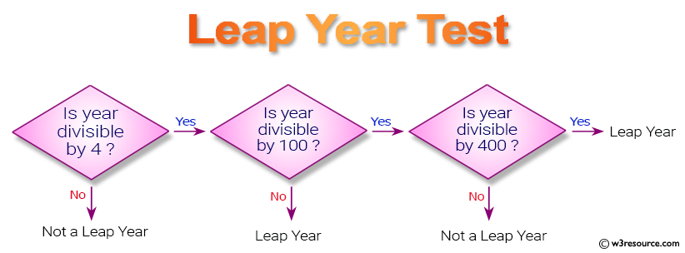

1. Write a C++ program that reads a positive integer and count the number of digits the number (less than 10 lac) has.

Input an integer number less than 10 lac: 125463  
*Expected Output*:

Number of digits in the number: 6

1. Write a C++ program to accept a coordinate point in a XY coordinate system and determine in which quadrant the coordinate point lies.
2. Write a C++ program to read temperature in centigrade and display a suitable message according to temperature state below:

Temp < 0 then Freezing weather  
Temp 0-10 then Very Cold weather  
Temp 10-20 then Cold weather  
Temp 20-30 then Normal in Temp  
Temp 30-40 then Its Hot  
Temp >=40 then Its Very Hot

1. Write a C++ program that reads an integer and first check either the number is positive or negative.
   1. If the number is positive, then check is it even or odd.
   2. If the number is negative, then first make it positive and check is it even or odd.
2. Write a C program to input basic salary of an employee and calculate its Gross salary according to following:

Basic Salary <= 10000 : HRA = 20%, DA = 80%

Basic Salary <= 20000 : HRA = 25%, DA = 90%

Basic Salary > 20000 : HRA = 30%, DA = 95%

1. Write a C program to input angles of a triangle and check whether triangle is valid or not.